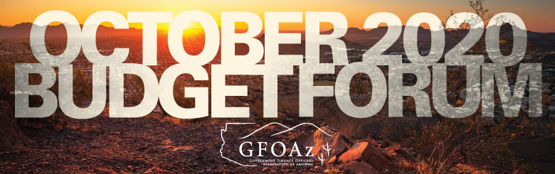

Session: Budgeting in Times of Uncertainty: How these cities budgeted during the Covid-19 pandemic
Date: Monday, October 26
Time: 10AM-12PM
2 CPEs

Speakers: Lindsay Duncan, Finance Director, Avondale
Peter Christensen, Management Analyst, Peoria
Mike Showers, Finance Director, Camp Verde

Session: The Changes to the Budget Awards Program and Budget Document Best Practices
Date: Thursday, October 29
Time: 11AM-12:30PM
1.5 CPEs

Speaker: John Fishbein, Senior Program Manager, GFOA

Session: Incremental Steps to Move Away from Incremental Budgeting
Date: Thursday, October 29
Time: 1:30PM-3:00PM
1.5 CPEs

Speakers: Brad Harris, Finance and Accounting Consultant, University of Tennessee-MTAS
Patti Hetrick, Budget Director, Anoka County
Walter C. Rossmann, Director of Finance, City of Milpitas

Description: Incremental budgeting is easy, convenient, and readily accepted as a standard process in government. However, is it the best approach? Incremental budgeting also makes it difficult to reallocate funding based on current priorities, compare funding to service levels or performance, or facilitate strategic long-term decision-making. Unfortunately, many governments never test what is best because changing a key organizational process is difficult. This session will provide a plan forward using smaller (achievable) steps to build a better budget process. Speakers will discuss how they were able to initiate efforts to reform the budget process and how they overcame common challenges along the way.

Session: Out Of The Ashes
Date: Wednesday, November 4
Time: 1PM-2PM
1 CPE

Speaker: Chad Hymas

Amidst all of the chaos, uncertainty and doubt of today's world, here are 5 principles you can apply today to rise up and be more productive, successful and see the opportunities that exist in the smoke!

